Write the roles of a 7 members team, named team Zeta ,for website development for Online learning Portal project using devops concepts. Also write the sprint and scrum and the roles of the members. Also provide the downloadable scrum dashboard for this using excel
Team Zeta (7 Members) – Online Learning Portal using DevOps
Member | Role | Responsibilities
Member 1 | Scrum Master | Conduct Daily Standups,Sprint Planning,Sprint Reviews, Sprint Retrospectives,Risk Management,Progress Tracking
Member 2 | Product Owner | Responsibilities  - Gather requirements  - Create user stories  - Prioritize backlog  - Stakeholder communication
Member 3 | DevOps Engineer | Application Architecture  Database Design  Security Design UML Diagrams
Member 4 | Frontend Developer | Student Module  - Login Page  - Dashboard  - Attendance Page  - Results Page  - Assignment Page  Faculty Module  - Login  - Attendance Entry  - Marks Upload  - Assignment Upload  Parent Module  - Login  - Student Progress Tracking  - Attendance Monitoring  GitHub Responsibilities  - Repository Setup  - Branch Management  - Pull Requests  - Code Reviews
Member 5 | Backend Developer | Database Tables  Students  - StudentID  - Name  - Course  - Semester  Faculty  - FacultyID  - Name  - Department  Parents  - ParentID  - StudentID  - ContactNumber  Attendance  - AttendanceID  - StudentID  - Subject  - Percentage  Results  - ResultID  - StudentID  - Semester  - GPA  APIs  Student APIs  Faculty APIs  Parent APIs
Member 6 | QA/Test Engineer | Functional Testing  - Student Login  - Faculty Login  - Parent Login  - Attendance Module  - Results Module  - Assignment Module  Automation Testing  - Selenium  - Postman API Testing
Member 7 | Cloud & Release Engineer | DevOps Tools  - Git  - GitHub  - Jenkins  - Docker  - Kubernetes  - Prometheus  - Grafana  Cloud Deployment  - AWS EC2  - Azure VM  Monitoring  - Application Monitoring  - Server Monitoring  - Log Management  Security  - SSL Certificates  - Role-Based Access Control  - Backup Management

Project: Online Learning Portal
Objective
Develop a web-based system for Online Learning Portal assets such as laptops, desktops, printers, software licenses, and network devices.

Scrum Roles
Product Owner
- Maintains Product Backlog
- Prioritizes user stories
- Defines acceptance criteria
Scrum Master
- Conducts Daily Scrum
- Facilitates Sprint Planning
- Removes impediments
- Ensures Scrum practices are followed
Development Team
- Designs, develops, tests, and deploys the application
- Delivers potentially shippable increments every sprint

Sprint Plan
Sprint Plan
Sprint 1 (Weeks 1–2)
Goal
Requirement Analysis & Environment Setup
Tasks
- Requirement Gathering
- User Stories
- Architecture Design
- GitHub Setup
- Jenkins Installation
Deliverables
- Product Backlog
- Architecture Document

Sprint 2 (Weeks 3–4)
Goal
Authentication & User Management
Tasks
- Student Login
- Faculty Login
- Parent Login
- Role-Based Access
Deliverables
- Authentication Module \
Sprint 3 (Weeks 5–6)
Goal
Academic Management
Tasks
- Attendance Module
- Assignment Module
- Results Module
- Notifications
Deliverables
- Academic Management System
Sprint 4 (Weeks 7–8)
Goal
DevOps & Deployment
Tasks
- Docker Containerization
- Jenkins Pipeline
- Automated Testing
- Cloud Deployment
- Monitoring Setup
Deliverables
- Production Deployment
- Monitoring Dashboard
Daily Scrum (15 Minutes)
Each member answers:
- What did I complete yesterday?
- What will I work on today?
- Are there any blockers?

Example:
Member | Yesterday | Today | Blocker
Frontend Developer | Login UI | Dashboard UI | None
Backend Developer | Authentication API | Asset API | None
QA Engineer | Login Testing | API Testing | Waiting for API

DevOps Tools
Activity | Tool
Version Control | Git
Repository | GitHub
CI/CD | Jenkins / GitHub Actions
Containerization | Docker
Monitoring | Prometheus, Grafana
Issue Tracking | Jira
Cloud Deployment | AWS / Azure

Team_Zeta_Online_Learning_Portal_Dashboard.xlsx

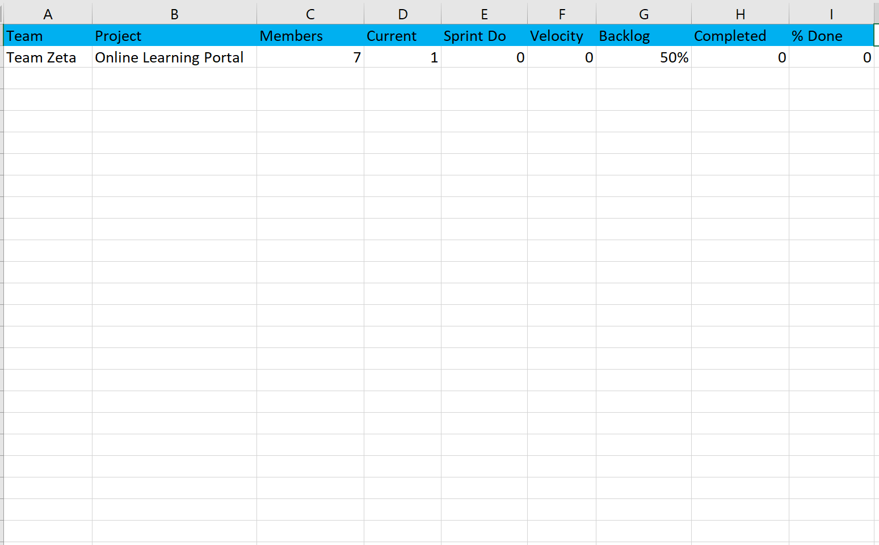

Scrum DashboardTeam RolesSprint Plan
The workbook contains:
- Scrum Dashboard
- Team Roles
- Sprint Plan

Responsibilities of each member in detail

Team Zeta – Detailed Roles and Responsibilities
Project: Online Learning Portal using DevOps
Modules: Student Login, Faculty Login, Parent Login, Course Management, Attendance Management, Assignment Management, Results Management, Notifications

1. Member 1 – Scrum Master
Primary Responsibility
Ensure the team follows Scrum practices and completes sprint goals on time.

Detailed Responsibilities
Sprint Management
- Conduct Sprint Planning meetings.
- Organize Daily Scrum meetings.
- Schedule Sprint Review and Retrospective meetings.
- Monitor sprint progress using Scrum Dashboard.
Team Coordination
- Coordinate among developers, testers, and DevOps engineers.
- Ensure tasks are evenly distributed.
- Track blockers and project risks.
Project Tracking
- Monitor sprint velocity and burndown charts.
- Ensure user stories are completed within sprint deadlines.
- Update Jira/Trello boards regularly.
Example Tasks
- Conduct daily stand-up meetings.
- Review sprint backlog.
- Track unresolved issues.
- Communicate project status to stakeholders.
Deliverables
- Sprint Plans
- Sprint Reports
- Burndown Charts
2. Member 2 – Product Owner
Primary Responsibility
Define system requirements and prioritize features based on stakeholder needs.
Detailed Responsibilities
Requirements Gathering
- Meet with students, faculty, parents, and administrators.
- Collect requirements for online learning activities.
- Define portal objectives.
Product Backlog Management
Create and Prioritize User Stories
- Student Registration & Login
- Faculty Login
- Parent Login
- Attendance Management
- Assignment Submission
- Result Viewing
- Course Management
- Notifications
Example User Story
As a Student, I want to view my attendance online so that I can track my academic progress.
Acceptance Criteria
- Student must log in successfully.
- Attendance percentage should be displayed.
- Attendance data should be updated automatically.
- Semester-wise attendance should be available.
Deliverables
- Product Backlog
- User Stories
- Acceptance Criteria
- Requirement Specification Document

3. Member 3 – DevOps Engineer
Primary Responsibility
Automate building, testing, and deployment of the Online Learning Portal.
Detailed Responsibilities
Source Code Management
- Create Git Repository.
- Define Branching Strategy.
- Manage Pull Requests.
CI/CD Pipeline Development
Pipeline Flow
- Code Commit
- Build Application
- Run Automated Tests
- Create Docker Image
- Deploy to Cloud Server
Docker Containerization
- Create Dockerfiles.
- Build application containers.
- Manage Docker images.
Automation
- Automate deployments.
- Automate testing.
- Configure GitHub Webhooks.
Monitoring
- Configure Prometheus.
- Create Grafana Dashboards.
- Monitor application health and uptime.
Deliverables
- CI/CD Pipeline
- Docker Containers
- Deployment Scripts
- Monitoring Dashboards

4. Member 4 – Frontend Developer
Primary Responsibility
Develop the user interface of the Online Learning Portal.
Detailed Responsibilities
User Interface Development
Pages to Develop
Student Module
- Login Page
- Student Dashboard
- Attendance Page
- Assignment Page
- Results Page
Faculty Module
- Faculty Login
- Attendance Entry Page
- Assignment Upload Page
- Marks Entry Page
Parent Module
- Parent Login
- Student Progress Dashboard
- Attendance Monitoring Page
- Result Monitoring Page
UI Design
- Create responsive layouts.
- Ensure mobile compatibility.
- Improve user experience.
API Integration
- Connect frontend with backend APIs.
- Display academic information dynamically.
Example Dashboard Features
Student Dashboard
Displays:
- Attendance Percentage
- Assignment Status
- Course Information
- Semester Results
Deliverables
- Web Pages
- Responsive Design
- API Integration

5. Member 5 – Backend Developer
Primary Responsibility
Develop server-side functionality and business logic.
Detailed Responsibilities
Database Design
Students Table
- StudentID
- StudentName
- Email
- Course
- Semester
Faculty Table
- FacultyID
- FacultyName
- Department
- Email
Parents Table
- ParentID
- ParentName
- StudentID
- ContactNumber
Attendance Table
- AttendanceID
- StudentID
- Subject
- AttendancePercentage
Results Table
- ResultID
- StudentID
- Semester
- GPA
Assignments Table
- AssignmentID
- Subject
- DueDate
- SubmissionStatus
API Development
Student APIs
GET /student/profile
GET /student/attendance
GET /student/results
GET /student/assignments
Faculty APIs
POST /attendance
POST /marks
POST /assignments
GET /students
Parent APIs
GET /parent/student-progress
GET /parent/attendance
GET /parent/results
Business Logic
- Attendance Validation
- Assignment Submission Validation
- Result Calculation
- Student Progress Tracking
Security
- Authentication
- Authorization
- Password Encryption
- Session Management
Deliverables
- Database Schema
- REST APIs
- Business Logic Modules

6. Member 6 – QA/Test Engineer
Primary Responsibility
Ensure the Online Learning Portal works correctly and is free from defects.
Detailed Responsibilities
Test Planning
Prepare:
- Test Plan
- Test Cases
- Test Scenarios
Functional Testing
Verify:
- Student Login
- Faculty Login
- Parent Login
- Attendance Management
- Assignment Submission
- Result Viewing
- Notifications
Automation Testing
- Selenium Scripts
- API Testing using Postman
Bug Tracking
Bug ID | Description | Status
BUG001 | Student Login Failure | Open
BUG002 | Attendance Not Updating | Fixed
BUG003 | Assignment Upload Error | Open
Regression Testing
- Verify old features after updates.
- Ensure new code doesn't break existing functionality.
Deliverables
- Test Cases
- Bug Reports
- Test Summary Reports

7. Member 7 – Cloud & Release Engineer
Primary Responsibility
Deploy and maintain the Online Learning Portal on cloud infrastructure.
Detailed Responsibilities
Cloud Setup
Provision:
- Virtual Machines
- Databases
- Storage Services
Using:
- AWS EC2
- Azure Virtual Machines
- Google Cloud VM
Deployment
- Configure Web Servers.
- Deploy Docker Containers.
- Manage Production Releases.
Monitoring
Track:
- CPU Usage
- Memory Usage
- Application Uptime
- Response Time
Backup & Recovery
- Database Backups
- Disaster Recovery Planning
- Restore Procedures
Security Management
- SSL Certificates
- Firewall Rules
- Access Control Management
Deliverables
- Cloud Infrastructure
- Production Environment
- Monitoring Reports
- Backup Strategy

Responsibility Matrix (RACI)
Activity | SM | PO | DevOps | Frontend | Backend | QA | Cloud
Requirements | C | A/R | I | I | I | I | I
Sprint Planning | A/R | R | C | C | C | C | C
UI Development | I | C | I | A/R | C | C | I
API Development | I | C | I | C | A/R | C | I
Testing | I | I | C | C | C | A/R | I
CI/CD Pipeline | I | I | A/R | C | C | C | C
Cloud Deployment | I | I | C | I | C | I | A/R
Monitoring | I | I | R | I | I | I | A/R
Legend:
- A = Accountable
- R = Responsible
- C = Consulted
- I = Informed
This structure closely matches how a real-world Agile DevOps team would develop and deploy an IT Asset Management web application over 4 sprints.

